**5G mmWave Channel Model Alliance**

**Measurement Scenario Parameter List**

**(MSP)**

What are “Measurement Scenario” parameters?

* Measurement Scenario parameters describe the key physical parameters of the scenario environment where the measurements were made.
* These parameters (listed further below) include dimensions of the measurement area, density and type of obstructions and type of materials for walls, ground and buildings.

Why we need to include Measurement Scenario Parameters? (MSP)

* Because of the small size of the mmWavelengths, the environment has a great effect on the channel measurements, and indeed, the environment is what largely defines the “channel”.[1]
* Recording the scenario parameters as part of the measurement process is intended to help to categorize and understand how the environment affects the “channel”. Some channel modeling, for example, may make use of some scenario parameters as part of the model.
* While some scenario categorization may occur from generic site labels such as indoor, outdoor, roadway, open-square, stadium or theatre, suburban, (InH, UMi, UMa, etc.) the recording of measurements of the scenario environment may help quantify re-use of the channel measurements for modeling similar, but not identical, environments/scenarios.

Measurement Scenario Parameters

* Key environment dimensions should be measured and recorded.
* The entries should be short, concise, and self-explanatory. Please use references if you need to provide more detailed explanations.
* Photographs of the measurement scene should be provided because they are often helpful in understanding the scenario, the measurement results and their extension to other environments.
* Sometimes seemingly anomalous propagation measurements may be the consequence of detailed facets of the environment. For example, a preponderance of horizontal or vertical elements in the environment may influence the polarization characteristics of the propagation.
* As we know, there is perhaps no “typical” environment/scenario for radio propagation measurement that exemplifies all conditions at the same time. So please don’t hesitate to indicate if a certain parameter is not considered with your scenario or, for example, if additional scenario parameters are considered critical to understanding the measurements.

|  |  |
| --- | --- |
| Parameter | Parameter description |
| **Basic scenario physical parameters** | |
| Shape | Open, rectangular, roadway, street, room, corridor, atrium, stadium, scene etc. Obstructions partitions doorways, windows, occupants. |
| Shape: Downtown, urban, roadway. |
| Dimensions/Site-map | Open length, widths, heights. Site map, floor plan (and vertical plan if necessary). |
| Map is attached at the end. |
| Tx Antenna location | Corner, wall, ceiling, floor, open. Height (above floor/ground), pointing angle. |
| TX position is marked on the map. TX height: 2.5 m. |
| Rx Antenna location | Corner, wall, ceiling, floor, open. Height (above floor/ground), pointing angle. |
| RX path: attached at the end. RX height: 1.6 m. |
| Transmitter – receiver separation | Distance (direct or obstructed), transmission path length if different than direct. |
| LOS or NLOS |
| Angle of arrival and angle of departure |
| Range of transmitter – receiver separations, including the location increment for fixed measurements sequences and/or the velocity for continuous measurements. |
|  | Range of TX – RX separations: 5 ÷ 26 m (LOS), 55 ÷ 115 (NLOS) |
| **Basic scenario materials** | |
| Walls (street façade) | Wood, concrete plaster, frame, brick, glass steel etc. Panel dimensions. |
| Building exterior – brick, glass, concrete; Foliage |
| Ceilings (or open sky) | Wood, concrete plaster, frame, brick, glass steel etc. Panel dimensions. |
| Open sky (some trees as shown in pictures) |
| Floors (ground, pavement) | Ground material, wood, concrete, pavement, earth, rock, brick crushed stone, sand etc.  Smooth level, irregular. |
| Concrete, Pavement. |
| Obstructions (in room or street) | Partitions, furniture, lamp-posts, vehicles.  Typical dimensions width height |
| Foliage, people, vehicles. |
| Architectural details | Windows and doors and frames (metal/wood/glass) |
| Large reflecting or obstructing surfaces should be recorded.  Material properties (smooth, polished, irregular, scattering, wet, dry, snow, lakes/ponds etc.) |
|  | Trees (as shown in pictures) |
| Scene details | Lamp-posts, fences, signs, monuments, trash boxes, vehicles, motion, weather conditions (rain/snow) if unusual. |
| **Photographs** | |
| View from transmitter | Towards receiver |
| Other views (e.g. elevation) |
| View from receiver | Towards transmitter |
| Other views (e.g. elevation) |
| Scene overview | Marked with Tx and Rx locations and measurement routes |
|  | Photographs and measurement route are attached. |

1. Photographs

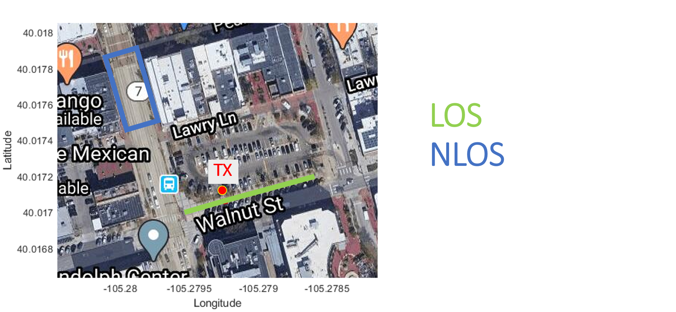

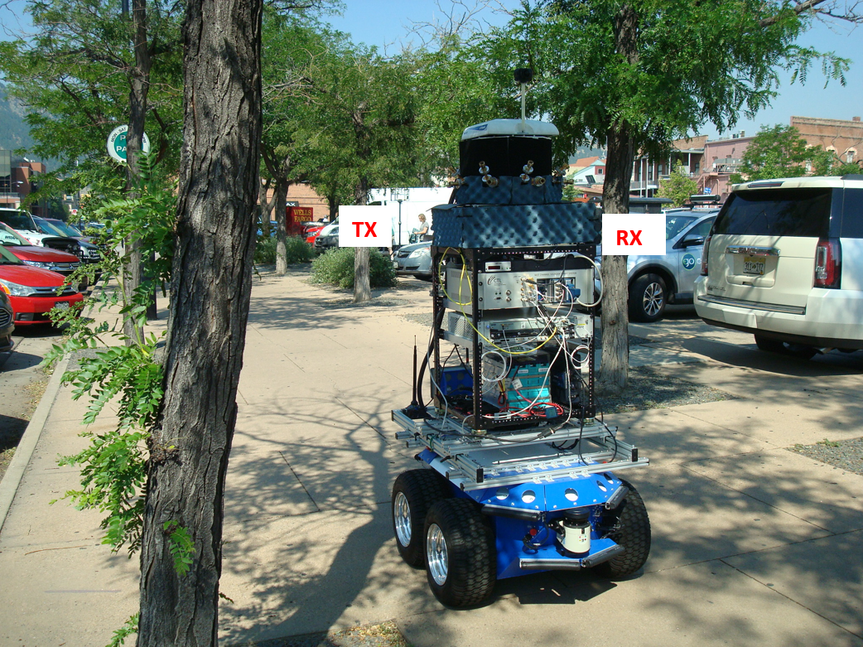

1. Consider - if the measurements were made in an “RF-anechoic” chamber there would not be very interesting channel results to report (beyond saying “free space”). The anechoic chamber serves to remove the local environment from the RF measurements. A real environment influences the channel measurements.